Why we need validation and sensitivity analysis?

We are developing a drought definition based on existing indices (i.e.SPI SPEI). A key challenge is choosing the right threshold — for example, should we say a drought starts when SPI drops below –0.5, –1.0, or –1.5?, Is SPI3 better than SPI6?

To answer this, we use ERA5 climate data and compare our drought definitions against ground-level evidence of drought stress — primarily NDVI (vegetation health from satellite) and soil moisture.

We use three statistical tools we use to measure how well each threshold definition performs:

Metric | What question it answers
Pattern Correlation Coefficient (PCC) | Do our drought events happen at the same time as NDVI stress?
Root Mean Square Error (RMSE) | How far off are the numbers in size/magnitude?
Critical Success Index (CSI) | Out of all real droughts, how many did we correctly catch?

- PCC — Did the Drought Happen at the Right Time?
Measures whether two variables go up and down together across time. Think of it this way: imagine two people watching the same river every month — one measures rainfall, the other checks if the fish are stressed. PCC asks: do they both agree on which months were bad?
- PCC = +1.0 → Perfect agreement. Every time SPI drops, NDVI drops too.
- PCC = 0.0 → No relationship. SPI and NDVI move independently.
- PCC = –1.0 → Opposite patterns (rare in this context).

What PCC does NOT tell you: It does not care about the size of the difference. SPI could say “slightly dry” while NDVI says “severe stress” — PCC might still be high if they go down at the same time.

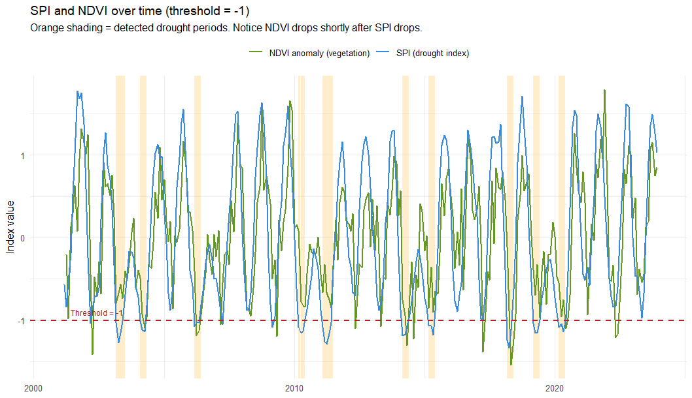
A PCC above 0.7 is generally considered a good match. But PCC alone is not enough — two measurements can be in sync but one could be far too large or too small.
Figure 1. Temporal variation in SPI and NDVI anomaly

- RMSE — Are the Numbers the Right Size?
What is RMSE?
Imagine we correctly predict when it will anomaly in SPI vs NDVI (good PCC!) but you always predict -0.5 in SPI when it actually NDVI -2. You have the timing right but the magnitude completely wrong.
RMSE measures the average size of the difference between your drought signal and the ground truth.
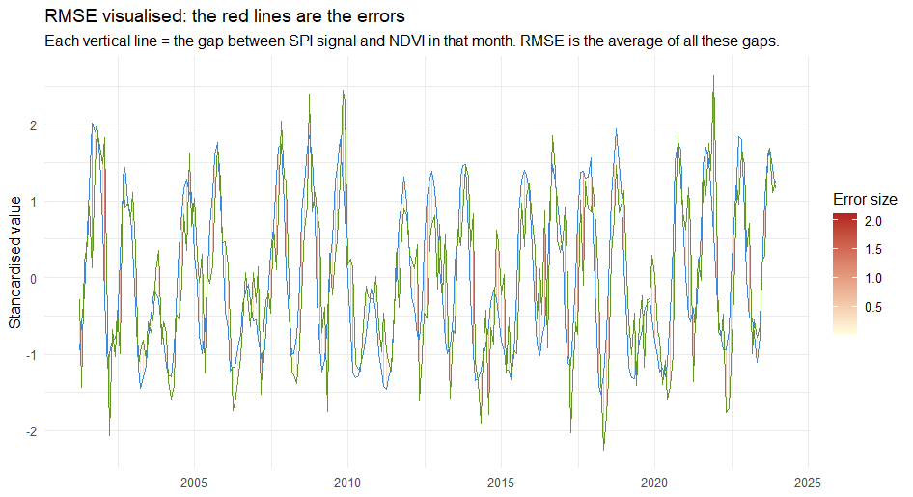
Figure 2. RMSE values based on SPI and NDVI

- CSI — Did We Catch the Real Droughts?
Even if PCC and RMSE are good, there is one more thing to check: did our definition actually detect the real drought events?
To answer this, we compare our detected drought months against a ground-truth drought label (months where both NDVI and soil moisture were below normal). Every month falls into one of four categories:
 | Ground Truth = Drought | Ground Truth = No Drought
We detect a Drought | Hit | False Alarm
We Detect No Drought | Miss | Correct Rejection

From this table we calculate three scores:
- POD (Probability of Detection) = Hits / (Hits + Misses) → Did we catch the real droughts?
- FAR (False Alarm Ratio) = False Alarms / (Hits + False Alarms) → How often did we cry wolf?
- CSI (Critical Success Index) = Hits / (Hits + Misses + False Alarms) → Overall skill, penalising both misses and false alarms.
CSI is the most important of the three because it balances both types of error. A perfect CSI = 1.0, a useless definition = 0.
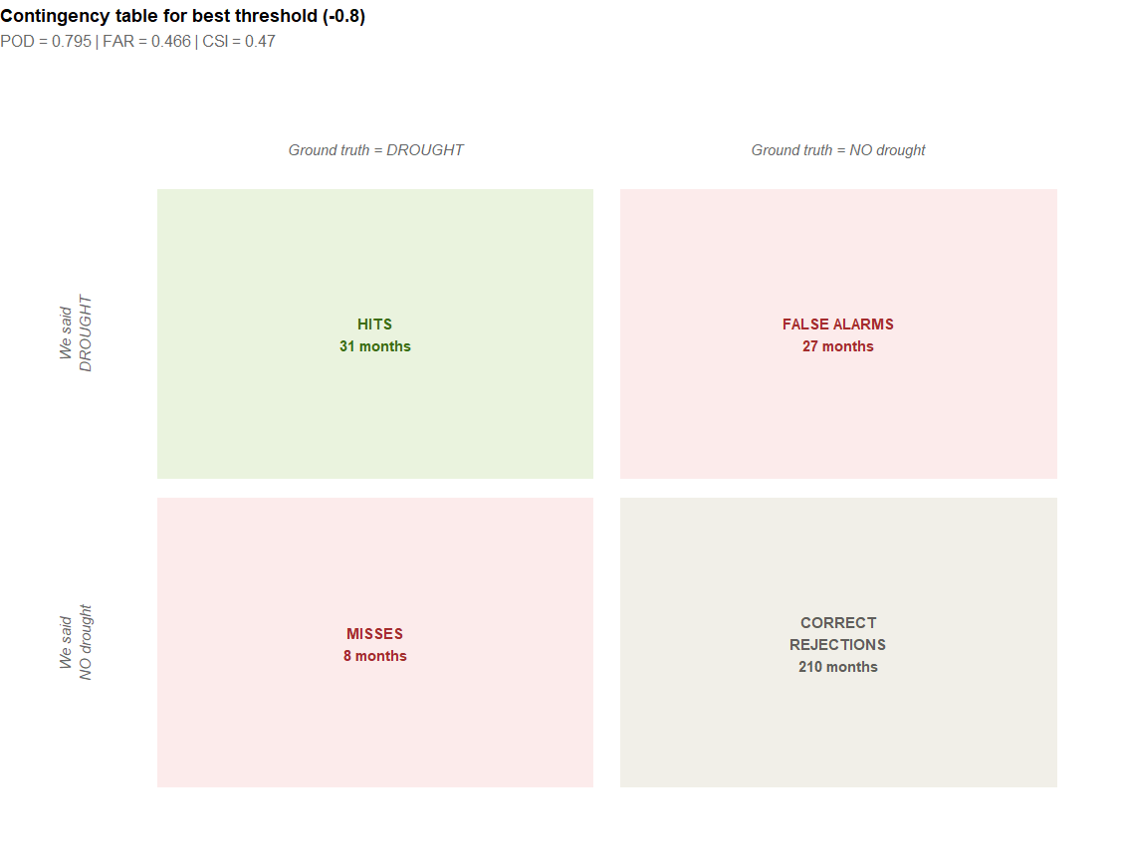

- Putting It All Together

Metric | What it measures | Good value | Bad value
PCC | Timing/direction agreement with NDVI | Close to 1 | Close to 0
RMSE | Magnitude of errors | As low as possible | High values
POD | Did we catch real droughts? | Close to 1 | Close to 0
FAR | How often did we cry wolf? | Close to 0 | Close to 1
CSI | Overall detection skill | Close to 1 | Close to 0

